**An Android Application For Keeping Up With The Latest Headlines**

**Introduction**

* 1. **Overview**

Project Description

This app display a list of latest news with news title, image, and a short description. It allows to tap on a headline to read detailed news. The app provides provisions to update latest news with relevant images which could be uploaded. This is done using Jetpack Compose UI toolkit to build the UI and it uses the coil library to load images.

Purpose

The app helps to be in touch with the latest news from all relevant fields.

Problem Definition and thinking

2.1. Empathy Map

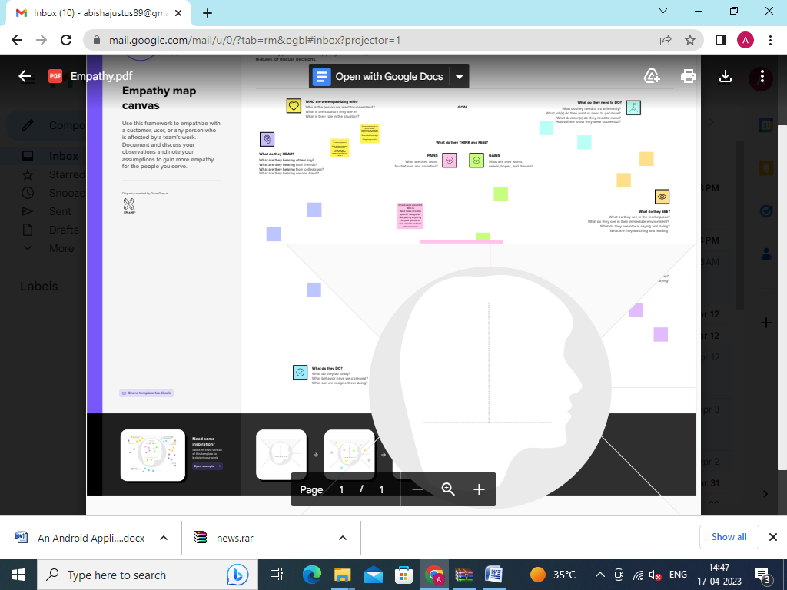

2.2. Ideation and Brainstorming Map

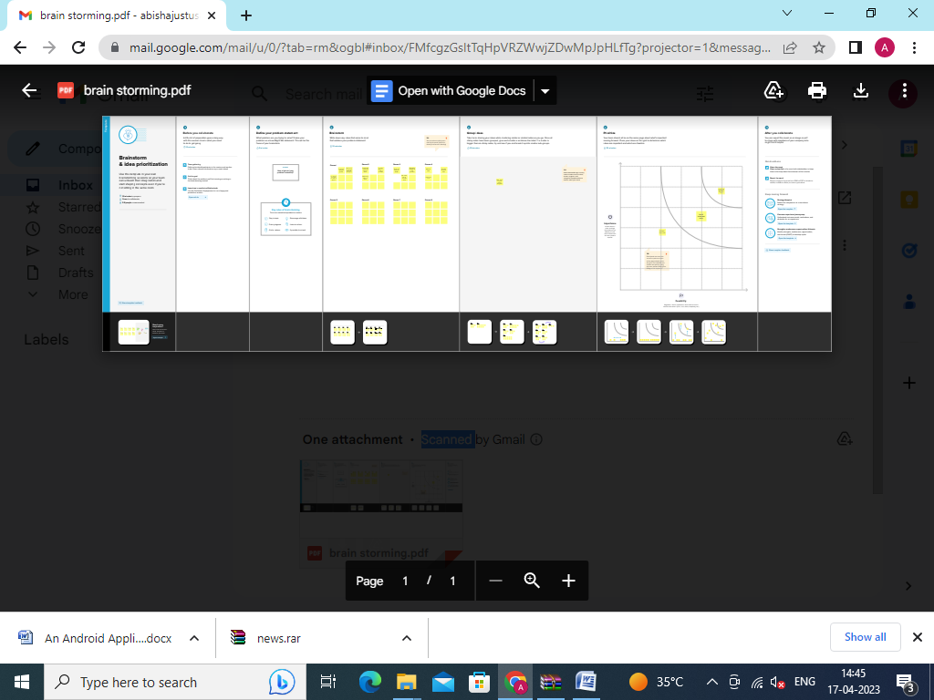

**Result**

Home Category

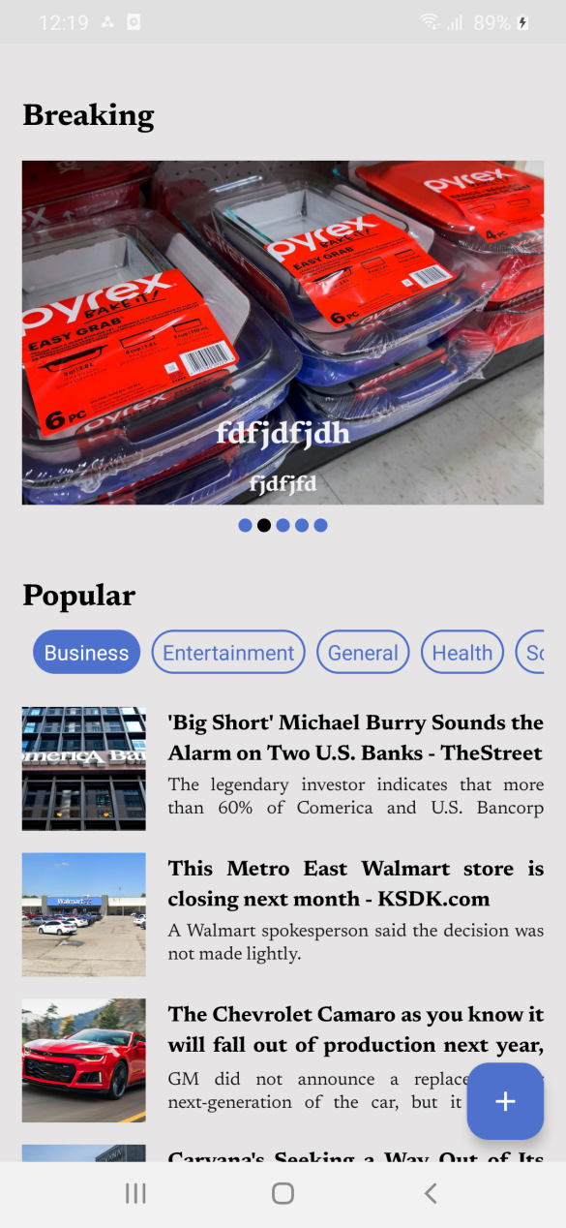 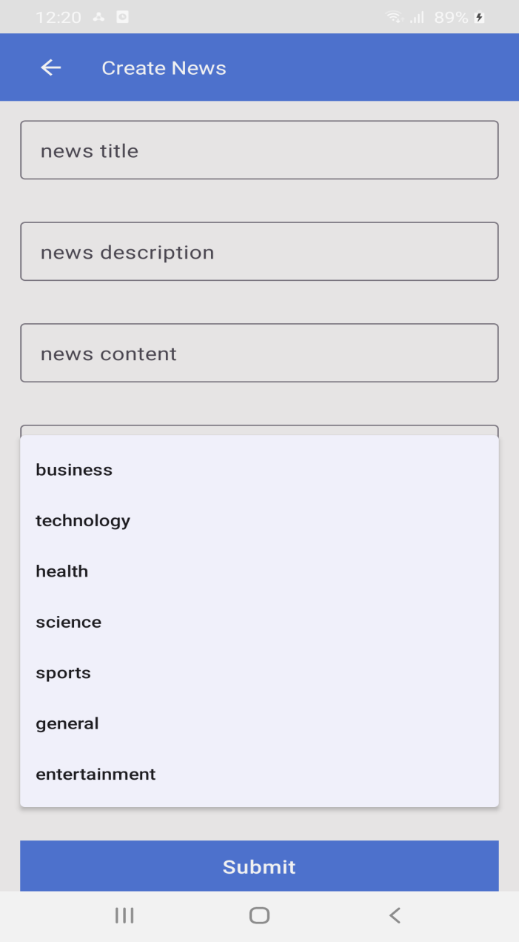

Choose Details

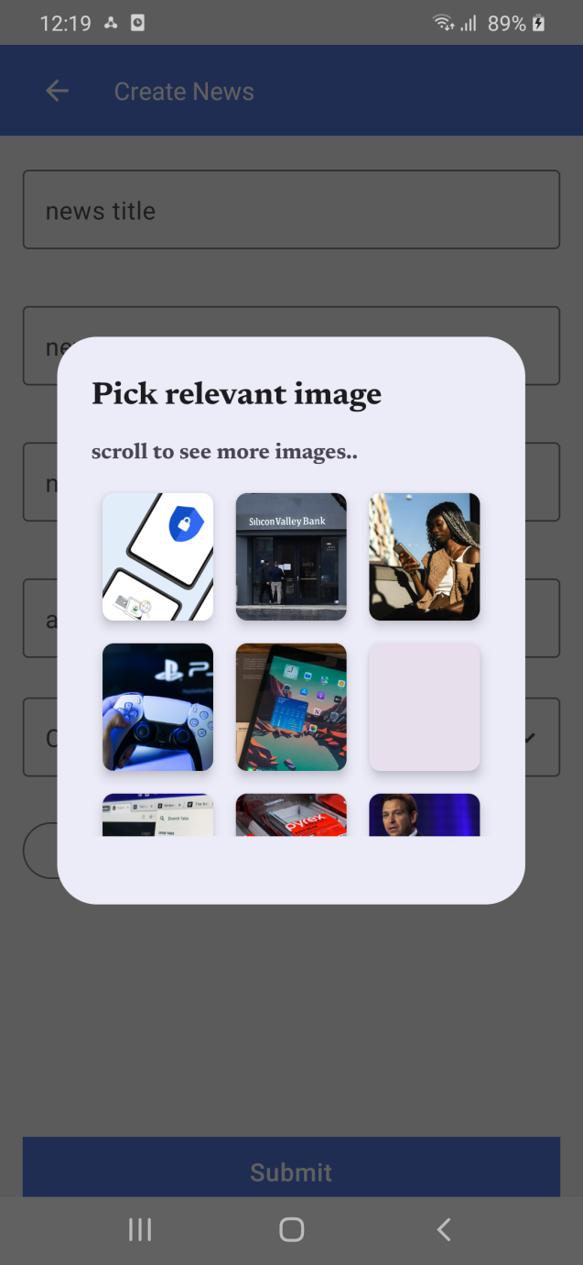 

Create Splash

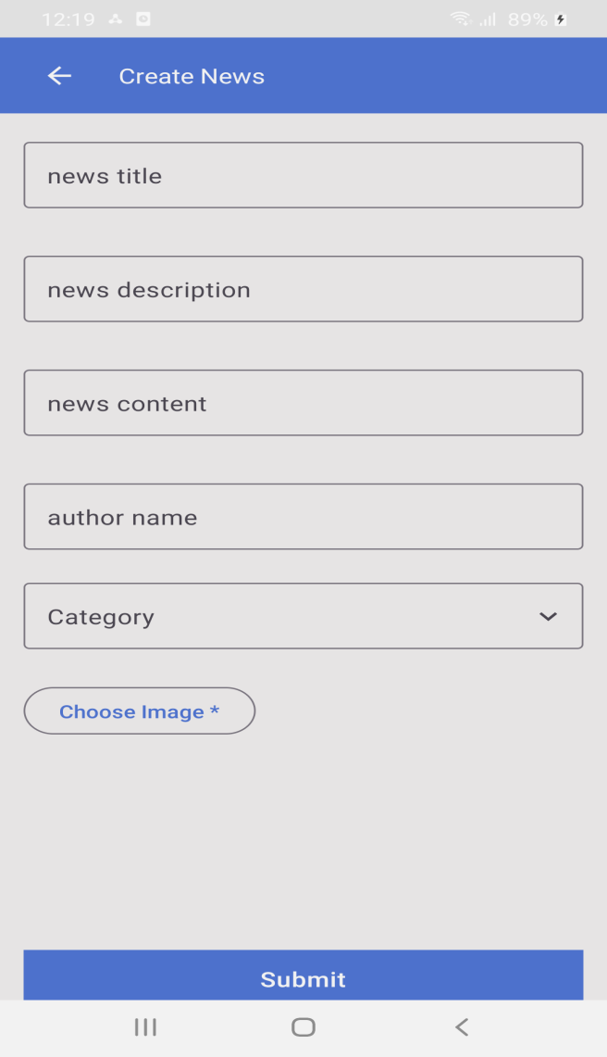 

**Advantages**

A particular news can be displayed based on the user preferences by taking the priority. This app makes available news in one place and user need not have to search the news of his preference again and again.

**Disadvantages**

The main drawbacks with the news app may be that it require data/wifi to get online and it does not provide the feel of reading it from a newspaper.

**Conclusion**

News and other informative articles published periodically are the contents of a newspaper. Online versions of newspaper are becoming a new trend that includes all the important headlines both national and international news as well as local news which are typical of general interest newspapers. The main headlines are inclusive of political events and personalities, business**, entertainment etc.**

**Future Scope**

The app could be modified to get notifications and also to provide better navigational ways.

**Appendix**

1. Source Code

AndroidManifest.xml

*<?***xml version="1.0" encoding="utf-8"***?>*<**manifest xmlns:android="http://schemas.android.com/apk/res/android"  
xmlns:tools="http://schemas.android.com/tools"**>  
  
<**uses-permission android:name="android.permission.INTERNET"** />  
  
<**application  
android:name="com.devikumari.news.base.NewsApp"  
android:allowBackup="false"  
android:icon="@mipmap/ic_launcher_foreground"  
android:roundIcon="@mipmap/ic_launcher_foreground"  
android:label="@string/app_name"  
android:supportsRtl="true"  
android:theme="@style/Theme.News"  
android:usesCleartextTraffic="true"  
tools:targetApi="31"** >  
<**activity  
android:name="com.devikumari.news.base.MainActivity"  
android:exported="true"** >  
<**intent-filter**>  
<**action android:name="android.intent.action.MAIN"** />  
  
<**category android:name="android.intent.category.LAUNCHER"** />  
</**intent-filter**>  
</**activity**>  
</**application**>  
  
</**manifest**>

**build.gradle**

buildscript**{**ext**{**gradle_version = **'7.4.1'**kotlin_version = **'1.8.0'**google_services_version = **'4.3.14'**compose_bom_version = **'2023.01.00'**material_version = **'1.1.0-beta01'**compose_version = **'1.4.0'**hilt_version = **'2.45'**hilt_navigation_compose_version = **'1.0.0'**firebase_bom_version = **'31.2.3'**constraintlayout_version = **'1.0.1'**coil_version = **'2.2.2'**accompanist_pager_version = **'0.18.0'**materialchip_version = **'3.0.5'**navigation_version = **'2.6.0-alpha05'  
}**dependencies **{**classpath**"com.google.gms:google-services:**$google_services_version**"**classpath**"com.google.dagger:hilt-android-gradle-plugin:**$hilt_version**"  
}  
}**plugins **{**id **'com.android.application'** version **"**$**{**gradle_version**}"** apply **false**id **'com.android.library'** version **"**$**{**gradle_version**}"** apply **false**id **'org.jetbrains.kotlin.android'** version **"**$**{**kotlin_version**}"** apply **false  
}**task clean(**type**: Delete) **{**delete rootProject.buildDir  
**}**

*#Wed Mar 22 22:44:54 IST 2023***distributionBase**=**GRADLE_USER_HOME  
distributionUrl**=**https\://services.gradle.org/distributions/gradle-7.5-bin.zip  
distributionPath**=**wrapper/dists  
zipStorePath**=**wrapper/dists  
zipStoreBase**=**GRADLE_USER_HOME**

**settings.gradle**

pluginManagement**{**repositories **{**google()  
mavenCentral()  
gradlePluginPortal()  
**}  
}**dependencyResolutionManagement**{**repositoriesMode.set(RepositoriesMode.FAIL_ON_PROJECT_REPOS)  
 repositories **{**google()  
mavenCentral()  
**}  
}**rootProject.name = **"news"**include **':app'**

**build.gradle(app)**

plugins **{**id **"com.android.application"**id **"kotlin-android"**id **"kotlin-kapt"**id **"com.google.gms.google-services"**id **"dagger.hilt.android.plugin"**id **"kotlin-parcelize"  
}**android **{**compileSdk33  
  
defaultConfig**{**applicationId**"com.devikumari.news"**minSdk21  
targetSdk33  
versionCode1  
versionName**"1.0"**testInstrumentationRunner**"androidx.test.runner.AndroidJUnitRunner"  
}**buildTypes**{**release **{**minifyEnabled**false**proguardFilesgetDefaultProguardFile(**'proguard-android-optimize.txt'**), **'proguard-rules.pro'  
}  
 }**compileOptions**{**sourceCompatibility JavaVersion.***VERSION_11***targetCompatibility JavaVersion.***VERSION_11*}**kotlinOptions**{**jvmTarget = JavaVersion.***VERSION_11*}**buildFeatures**{**compose **true  
}**composeOptions**{**kotlinCompilerExtensionVersioncompose_version  
**}**namespace **'com.devikumari.news'  
}**dependencies **{***//Compose*implementation platform(**"androidx.compose:compose-bom:**$compose_bom_version**"**)  
 implementation **"androidx.compose.material3:material3:**$material_version**"***//Hilt*implementation **"com.google.dagger:hilt-android:**$hilt_version**"**kapt**"com.google.dagger:hilt-android-compiler:**$hilt_version**"***//Hilt Navigation Compose*implementation **"androidx.hilt:hilt-navigation-compose:**$hilt_navigation_compose_version**"***//Firebase*implementation platform(**"com.google.firebase:firebase-bom:**$firebase_bom_version**"**)  
implementation**"com.google.firebase:firebase-firestore-ktx"***//ConstraintLayout*implementation(**"androidx.constraintlayout:constraintlayout-compose:**$constraintlayout_version**"**)  
*//Image Loading*implementation(**"io.coil-kt:coil-compose:**$coil_version**"**)  
*//pager*implementation(**"com.google.accompanist:accompanist-pager:**$accompanist_pager_version**"**)  
*//chips*implementation(**"com.robertlevonyan.compose:materialchip:**$materialchip_version**"**)  
*//navigation*implementation(**"androidx.navigation:navigation-compose:**$navigation_version**"**)  
**}**